**BT 307**

**1.)** Harsh Arora

200106034

**2.)** 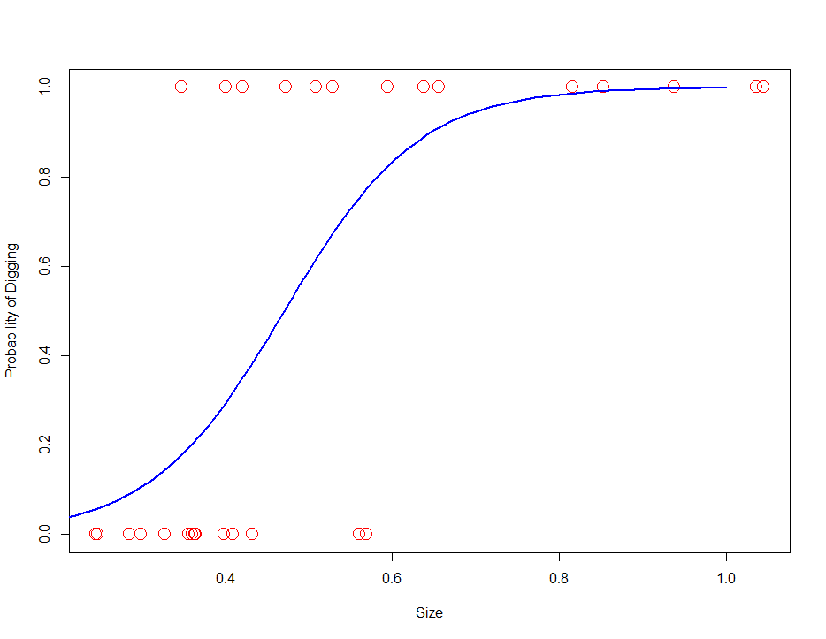

**3.)**

|  |  |  |
| --- | --- | --- |
| Predicted/Actual | 0 | 1 |
| 0 | 1 | 1 |
| 1 | 6 | 6 |

|  |  |  |
| --- | --- | --- |
| Predicted/Actual | 0 | 1 |
| 0 | 4 | 1 |
| 1 | 3 | 6 |

|  |  |  |
| --- | --- | --- |
| Predicted/Actual | 0 | 1 |
| 0 | 5 | 4 |
| 1 | 2 | 3 |

**4.)** 